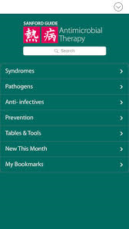
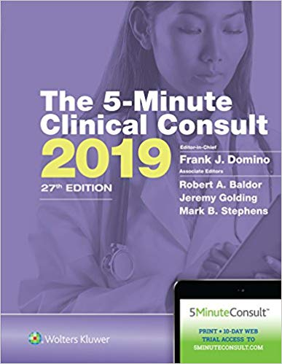
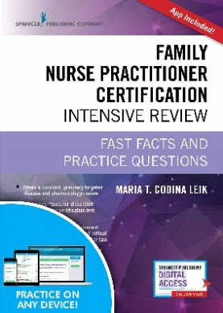
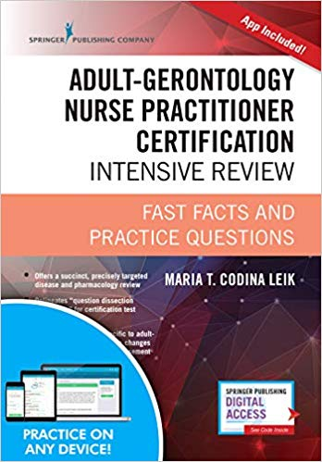
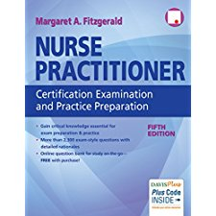
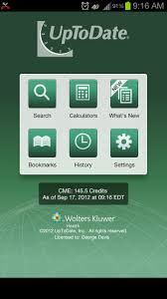
Clinical Resources

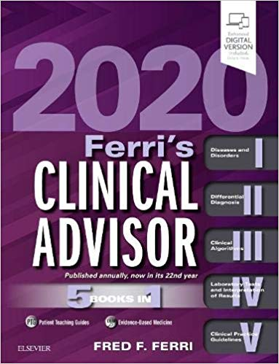
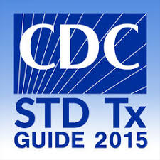
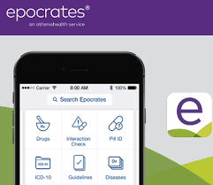
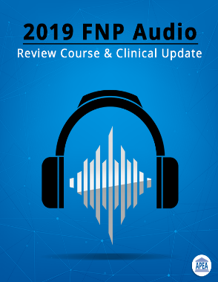
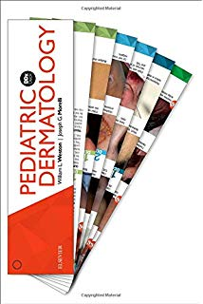
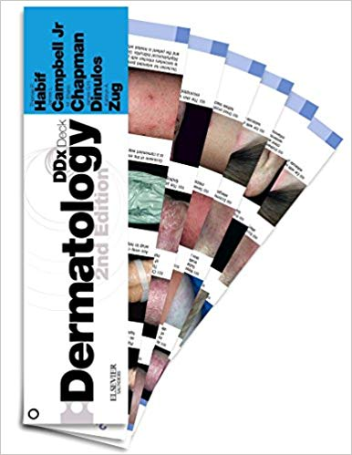

Amelie Hollier
Clinical resources most commonly used by the previous FNP cohort. The GNO recommends students start using some of these resources as early as Advanced Pathophysiology and Pharmacology. Students will likely use all resources for Clinical Decision Making, and as you advance into FNP I – III. Certification books will also prepare the student for ANCC or AANP boards. Mobile apps are helpful during clinical rotation.
The Graduate Nursing Organization wishes you the best of luck as you begin your studies. You can find us on https://mason360.gmu.edu
Follow us on Facebook and Instagram.

