

* Download the GooseChase Android or iPhone app.
* 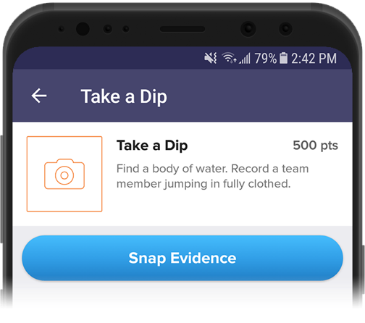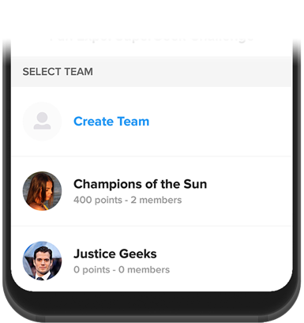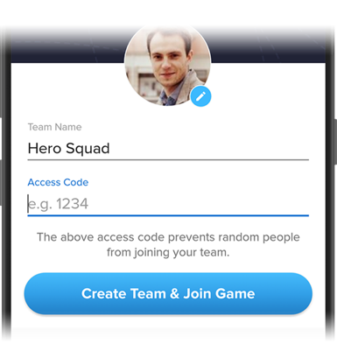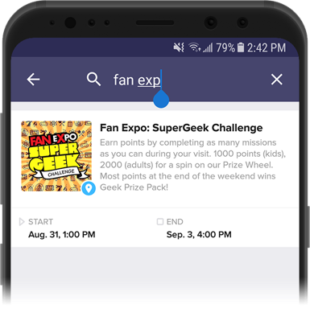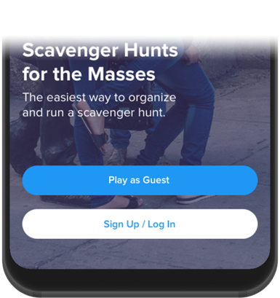Choose to play as a guest.
* Tap the search icon and Search Game Code **6DDQP6 (On-Campus/In-Person) or LKKVGM (Virtual).**
* Create your profile with you and/or your friends and enter your team name.
* Once in the game, you’ll be presented with the missions you or your team are attempting to complete. Mission types include Photo and Text response.
* To complete a mission, select it from the list and hit the “Snap Evidence” button.

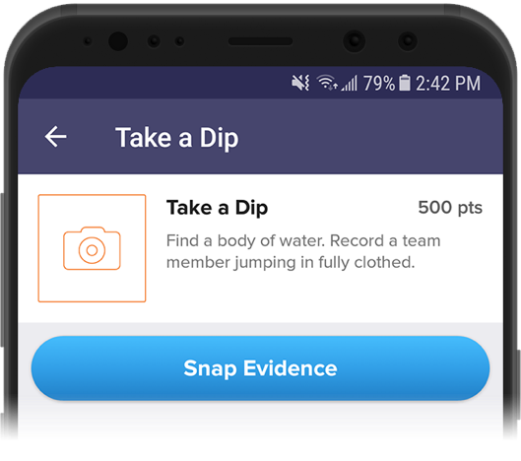

* Make sure you’re completing missions accurately! (e.g. “take a picture with a Zebra” means take a picture with a real Zebra, not next to a computer image)
* 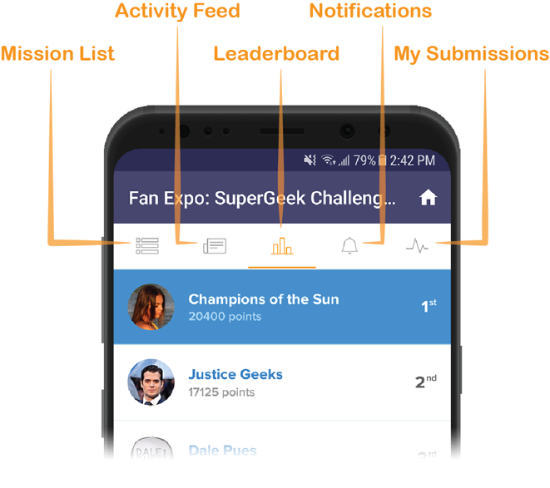Using the navigation tabs, you can keep track of how you are doing via the activity feed and the leaderboard, see notifications from the game organizer or review (and resubmit) your previous submissions.
* There will be a Prize-Winner for each hunt (On-Campus and Virtual). These will be announced over NSFP social media (Instagram @MasonNSFP).
* Most importantly, Have fun! and enjoy exploring Mason and beyond!

